**DIGITAL MARKETING ASSIGNMENT**

**NAME:** B. MOHAMMED IBRAHIM

**NAAN MUDHALVAN ID:** 3DB7C4EB846CB49ADAD4F00E95AB0734

1.Create a blog or website using Blogspot and WordPress. Customize the theme design and post new article with 500 words.

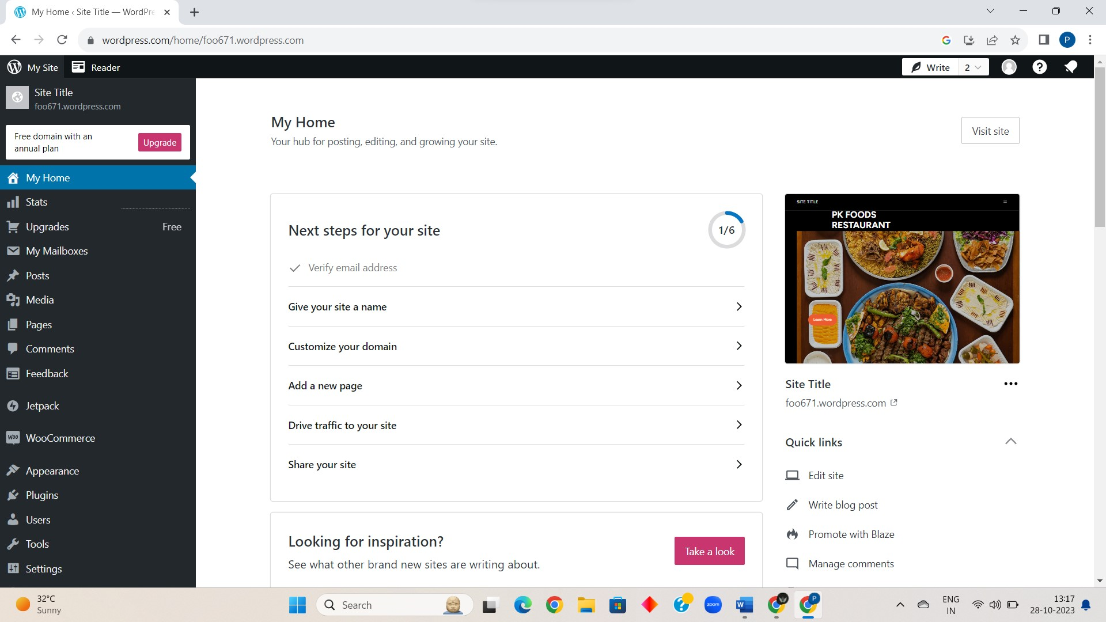

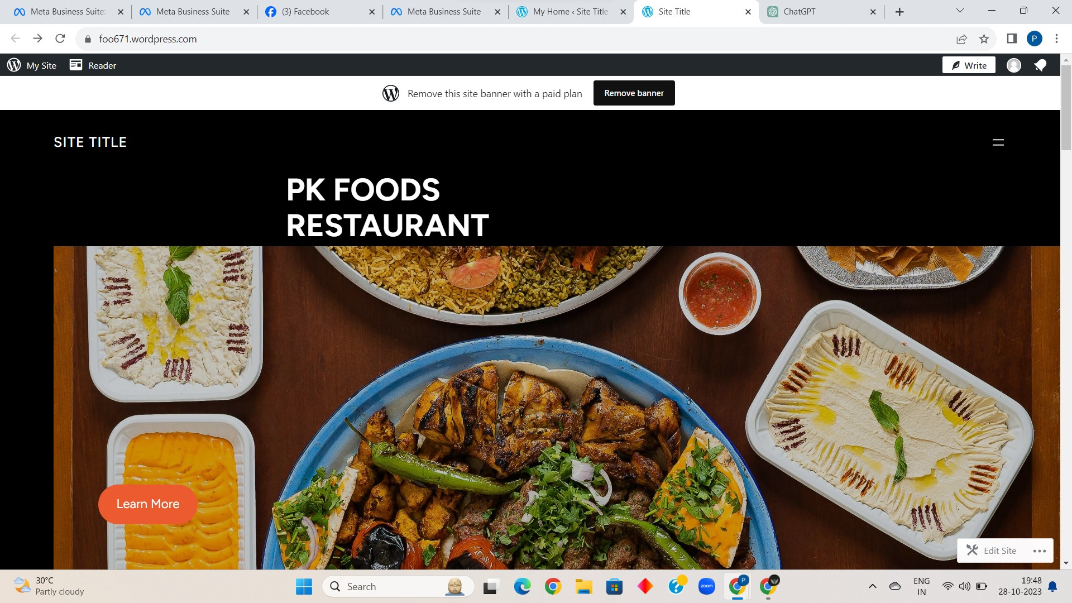

LINK:

<https://foo671.wordpress.com/>

2. Create a New Facebook Business Page and post one social media poster for your brand.

SCREENSHOT:

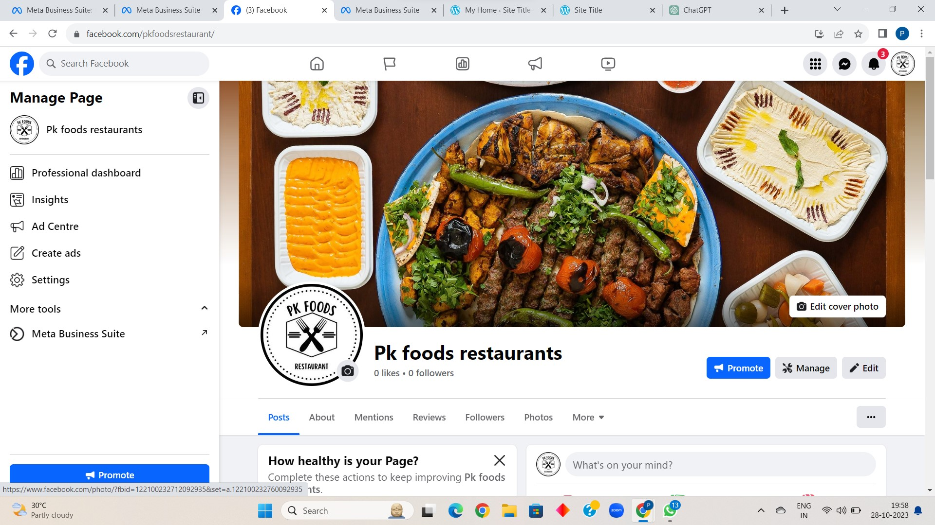

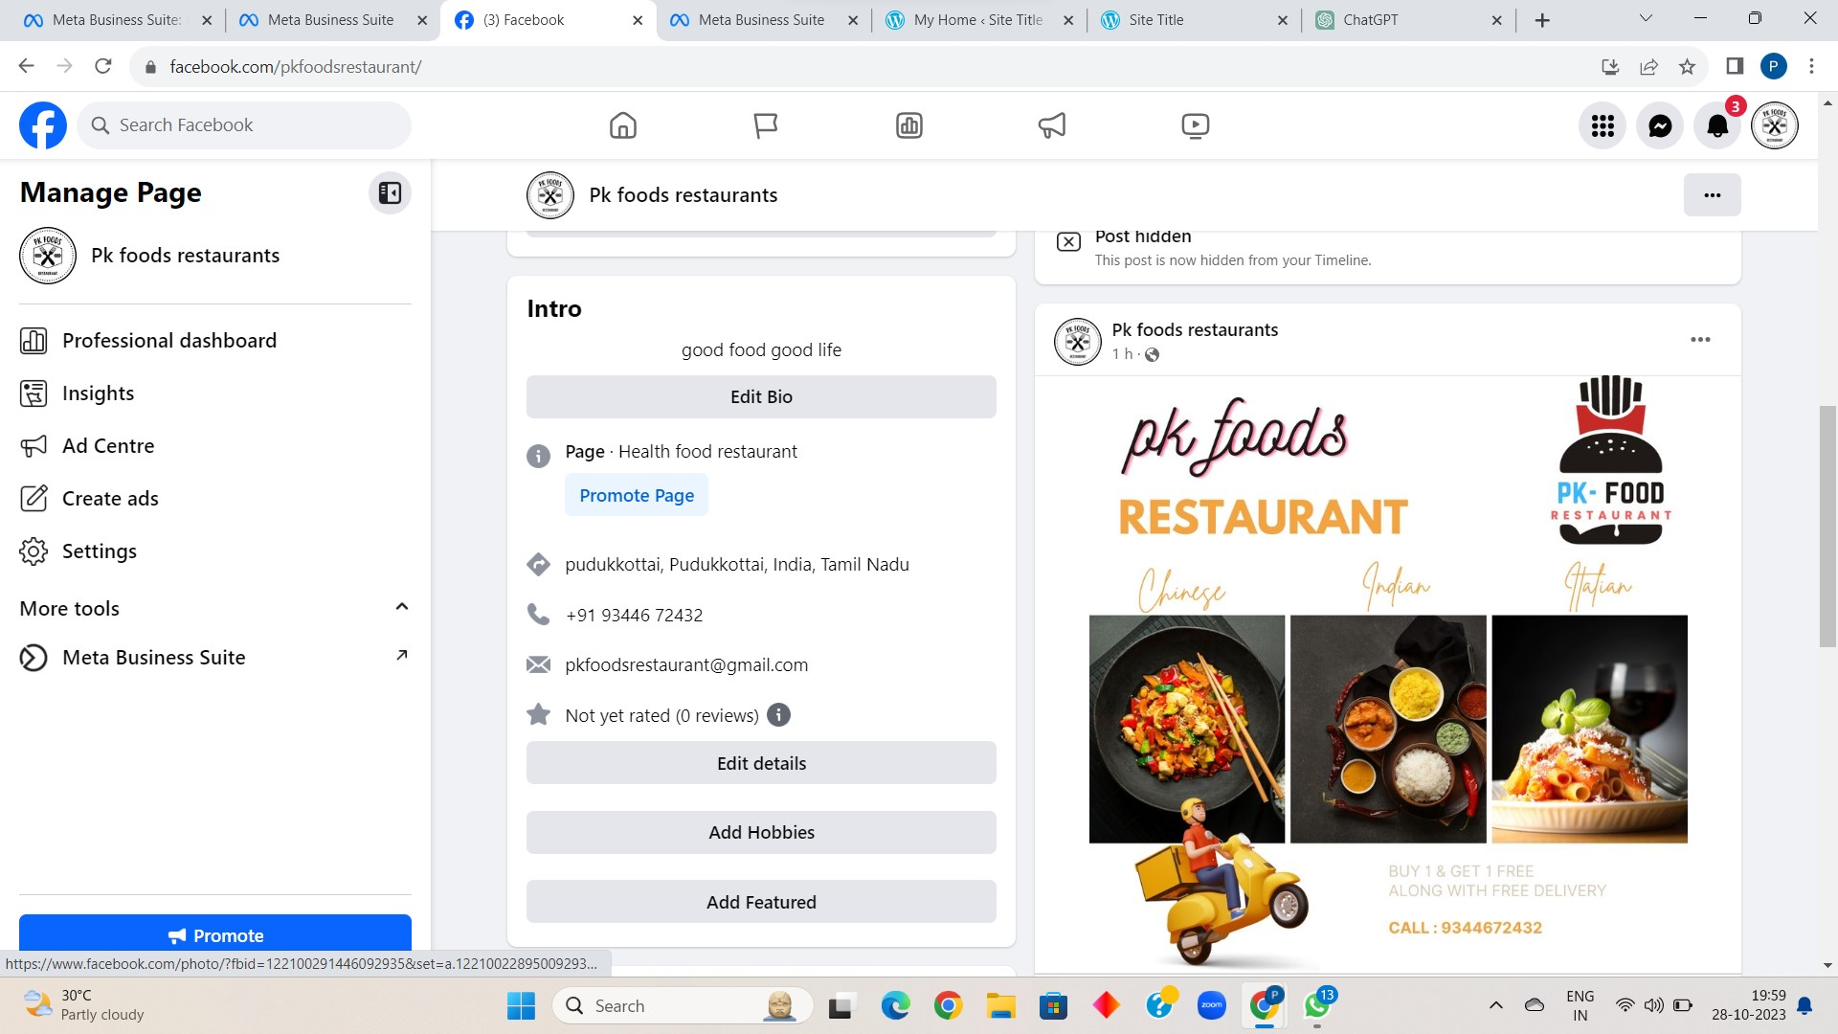

PROFILE LINK:

<https://business.facebook.com/latest?asset_id=166388233217995&nav_ref=mfb_get_started_header_cta>

POSTER LINK:

<https://www.facebook.com/pkfoodsrestaurant/posts/pfbid025U58DTSZT4mCEmbTCgeyLNeScL66Z4BKCjaMDB76jF2ekLpj88ox7gJFZLWYArnJl>

3. Create and design a social media advertisement poster using canva.

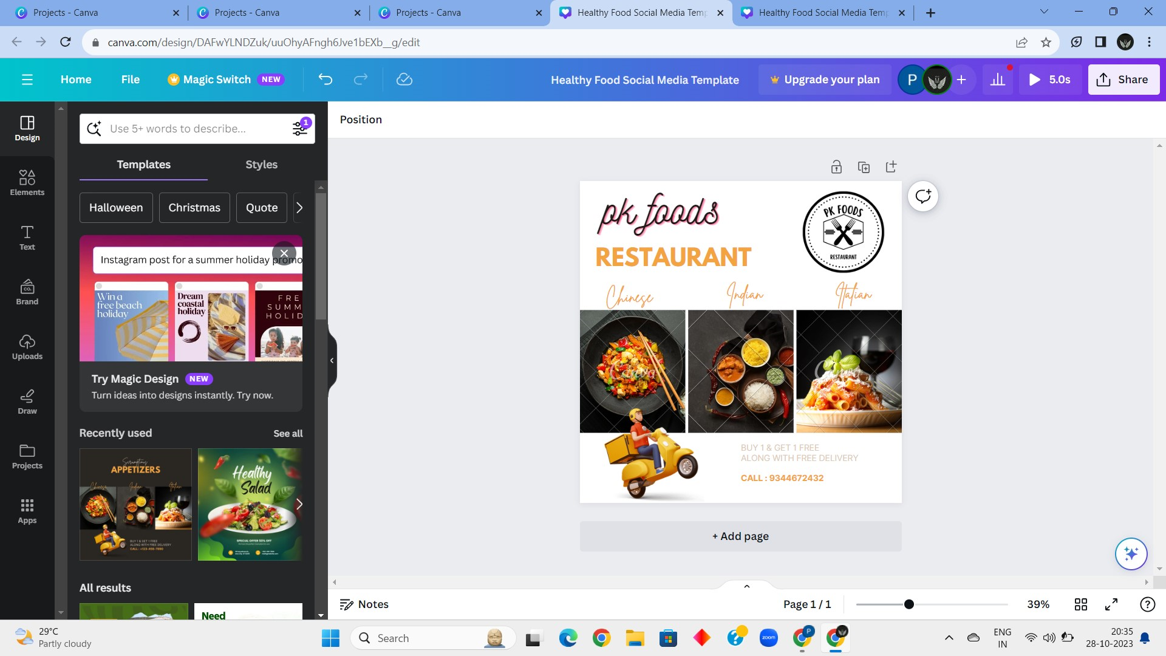

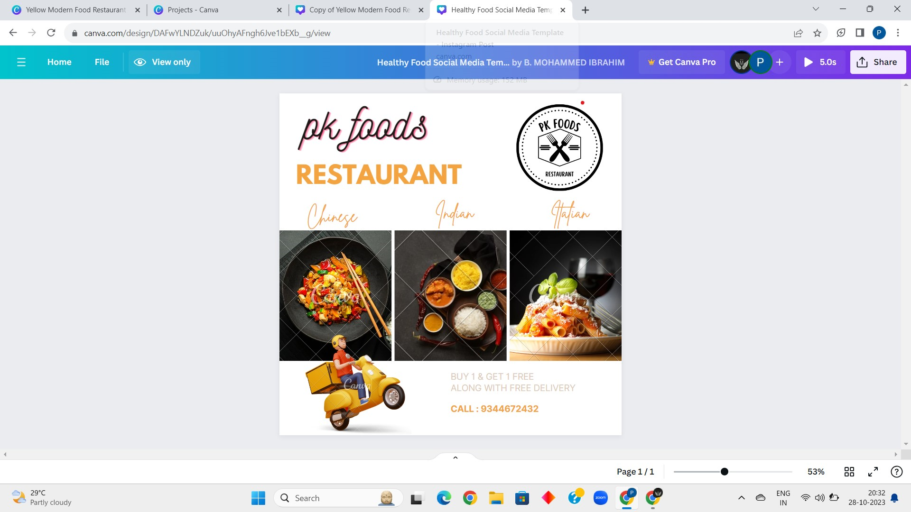

LINK:

<https://www.canva.com/design/DAFwYLNDZuk/uuOhyAFngh6Jve1bEXb__g/view>

4. Create email newsletter design using MailChimp or canva tool.

SCREENSHOT:

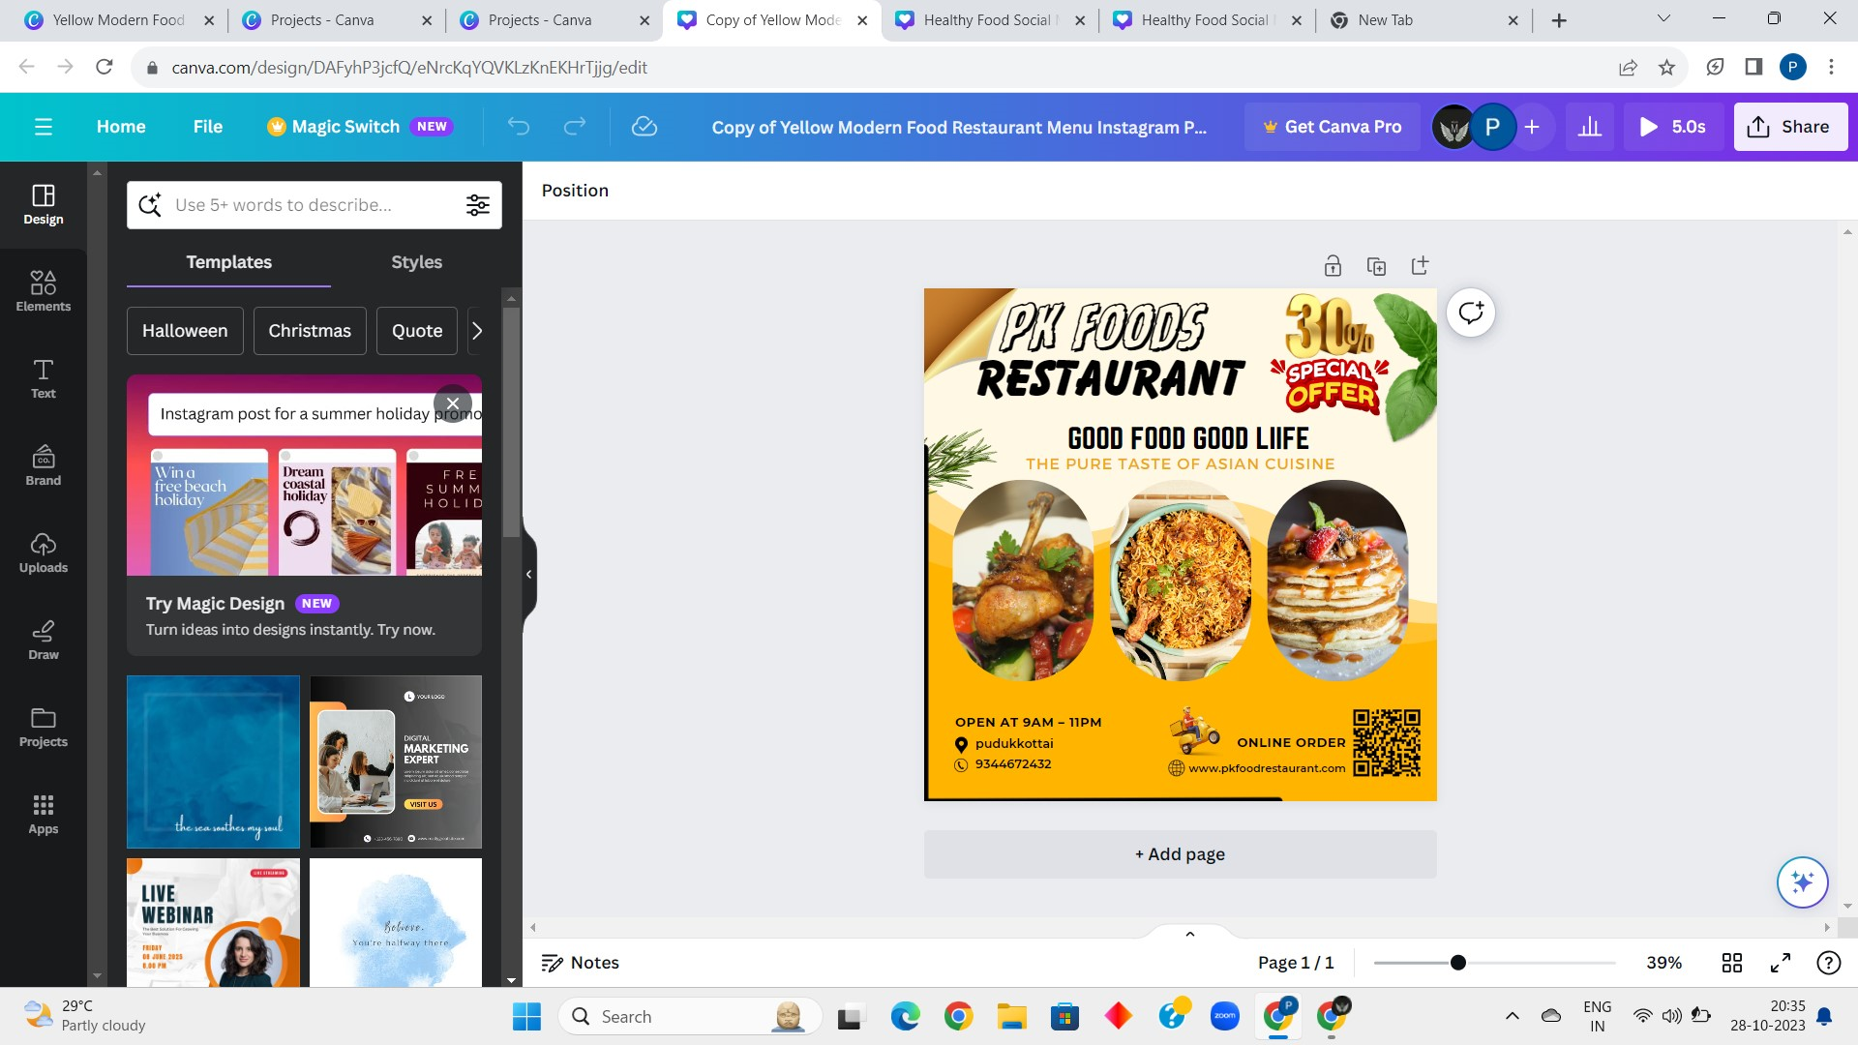

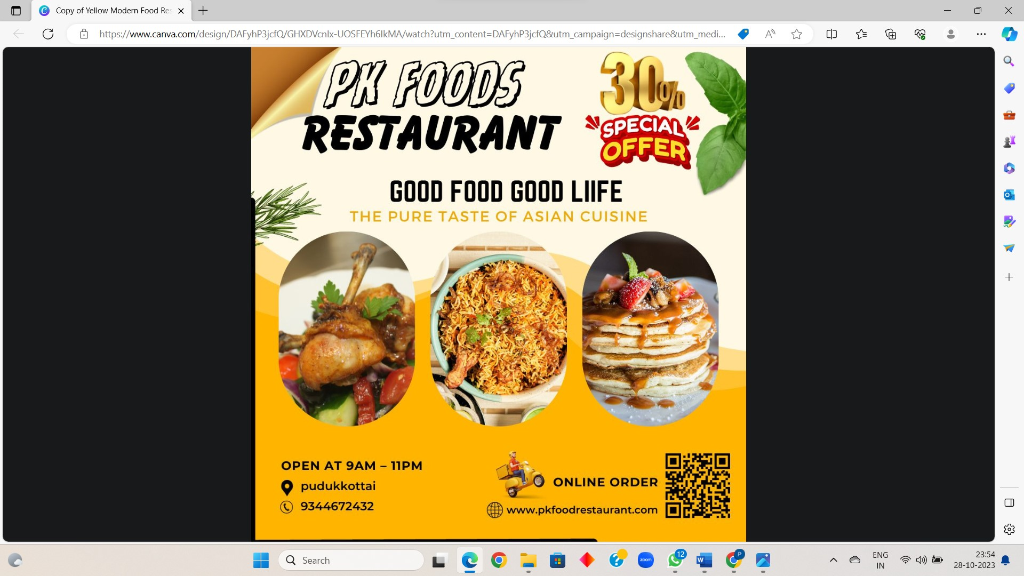

LINK:

<https://www.canva.com/design/DAFyhP3jcfQ/GHXDVcnIx-UOSFEYh6IkMA/watch?utm_content=DAFyhP3jcfQ&utm_campaign=designshare&utm_medium=link&utm_source=editor>